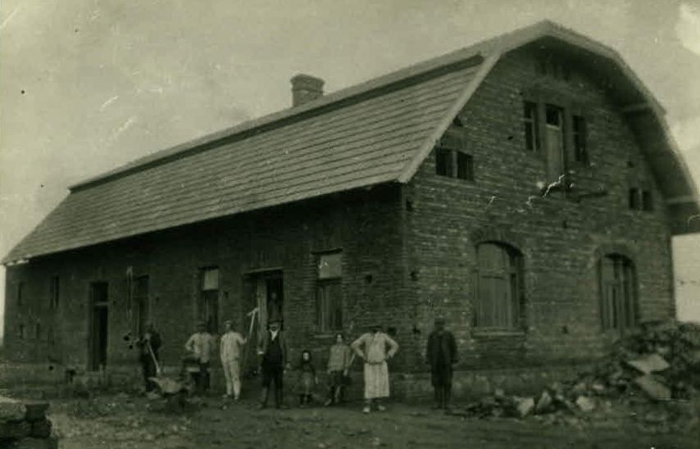

Pitkovice farm house being built near Uhrineves. Farm land was leased originally by Josef Beykovsky and managed by son Vilem, in the production of grains and fine horses. Siblings Anna, Gustav, Otto and Vilem were born here. Eventually September 1942, Vilem and family were ordered to appear for deportation, Vilem was found dead of self-poisoning, that morning.

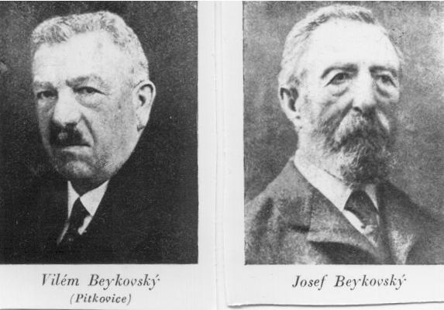

Photos before 1934.